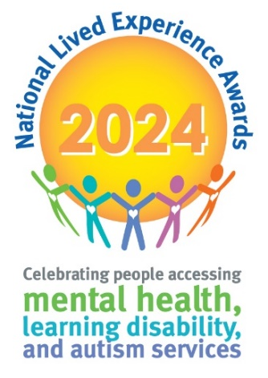**Service User Judging Panel Application Form**

**Please return expression of interest by Wednesday 26th June to** [**events@cygnethealth.co.uk**](mailto:events@cygnethealth.co.uk)**. Judging will take place at the Leonardo Hotel, Derby, DE1 3DB on Thursday 25th July, 11am – 4pm.**

Successful applicants will be notified by the 5th of July, and will also be invited to attend the awards ceremony on Tuesday 24th September 2024.

|  |  |
| --- | --- |
| **Service User Name** |  |
| **Hospital/Unit** |  |

**ALL APPLICATIONS WILL REQUIRE SUPPORT FROM A MEMBER OF YOUR CLINICAL TEAM WHO WILL BE ABLE TO SUPPORT YOU TO ATTEND THE JUDGING DAY / CEREMONY**

|  |  |  |
| --- | --- | --- |
| **Staff Name:** | |  |
| **Job role:** | |  |
| **Telephone No:** | |  |
| **Email Address** | |  |
| **Hospital / Unit:** |  |  |
| **Signature (may be signed by email)** |  |  |
| **Number of additional staff required to attend** |  |  |
| **I can confirm the relevant risk assessment has been completed for the individual to participate in the judging day** | | Sign here |

|  |
| --- |
| **Please tell us about why you would like to be a judge for this year’s National Service User Awards (no more than 150 words).** |
|  |
| **Please use the space below to tell us any other additional information you would like us to consider as part of your application.** |
|  |
| **Please share any specific needs and/or dietary requirements you may have** |
|  |